CHEMISTRY
UNITS 1 & 2
2024
MARKING GUIDE

Structure of this paper

Section | Number of questions available | Number of questions to be answered | Suggested working time  (minutes) | Marks available | Percentage of exam
Section One  Multiple-choice | 25 | 25 | 30 | 25 | 25
Section Two  Short answer | 9 | 9 | 50 | 62 | 35
Section Three  Extended answer | 4 | 4 | 70 | 74 | 40
 |  |  |  | Total | 100

Section One: Multiple-choice 25% (25 marks)

1 | a □ b □ c □ d ■ |  | 6 | a □ b □ c □ d ■ |  | 11 | a □ b □ c ■ d □
2 | a □ b □ c ■ d □ |  | 7 | a ■ b □ c □ d □ |  | 12 | a □ b □ c □ d ■
3 | a □ b ■ c □ d □ |  | 8 | a □ b ■ c □ d □ |  | 13 | a □ b ■ c □ d □
4 | a ■ b □ c □ d □ |  | 9 | a □ b ■ c □ d □ |  | 14 | a □ b ■ c □ d □
5 | a □ b ■ c □ d □ |  | 10 | a □ b □ c ■ d □ |  | 15 | a □ b □ c ■ d □

16 | a □ b □ c □ d ■ |  | 21 | a □ b □ c ■ d □
17 | a □ b □ c ■ d □ |  | 22 | a □ b ■ c □ d □
18 | a □ b □ c ■ d □ |  | 23 | a □ b □ c ■ d □
19 | a □ b □ c ■ d □ |  | 24 | a □ b ■ c □ d □
20 | a ■ b □ c □ d □ |  | 25 | a □ b □ c □ d ■

Section Two: Short answer 35% (62 marks)

Question 26 (4 marks)

(a) Name this molecule. (1 mark)

Description | Marks
Water | 1
Total | 1

(b) List the individual atoms in this molecule, using the notation ^{A}X. (2 marks)

Description | Marks
¹H | 1
¹⁷O | 1
Total | 2

(c) State the reason, in terms of electron arrangement, why these individual atoms formed chemical bonds to create this molecule. (1 mark)

Description | Marks
Recognition that a stable electron arrangement / full outer shell is achieved. | 1
Total | 1

Question 27 (6 marks)

(a) Describe how covalent bonding is formed. (2 marks)

Description | Marks
Recognition that electrons are shared. | 1
Recognition that covalent bonding:  is the electrostatic attraction between the shared electron pair(s) and the adjacent positive nuclei.  or  occurs between non-metals. | 1
Total | 2

(b) Explain, in terms of structure and bonding, why candle wax and glass exhibit such different physical strength. (4 marks)

Description | Marks
Recognition that candle wax is a covalent molecular substance / exists as discrete molecules. | 1
Recognition that there are weak intermolecular forces of attraction between the molecules (resulting in it being soft/waxy). | 1
Recognition that glass is a covalent network substance / forms extensive 3D covalent networks. | 1
Recognition that the extensive covalent bonds are very strong (resulting in it being hard/brittle). | 1
Total | 4

Question 28 (8 marks)

(a) Explain how this would allow identification of each solution. Your answer should include any relevant chemical equations. (4 marks)

Description | Marks
Recognition that a yellow solid/precipitate would form with the sodium carbonate solution. | 1
2 Ag⁺(aq) + CO₃²⁻(aq) → Ag₂CO₃(s) | 1
Recognition that a black solid/precipitate would form with the sodium sulfide solution. | 1
2 Ag⁺(aq) + S²⁻(aq) → Ag₂S(s) | 1
Total | 4
Note: state symbols are not required for full marks.

(b) Write a balanced ionic equation, and corresponding observations, for the reaction that would have taken place when hydrochloric acid was added to the beaker containing sodium carbonate solution. (4 marks)

Description | Marks
Equation
2 H⁺(aq) + CO₃²⁻(aq) → H₂O(l) + CO₂(g)
Correct species | 1
Correct balancing | 1
Observations
Two colourless solutions mixed | 1
Effervescence (bubbling) | 1
Total | 4

Question 29 (6 marks)

Complete the following table by identifying the element that matches the description, and writing the corresponding electron configuration for that element.

Description | Marks
Description Name of element Electron configuration  The metallic element, with 2 valence electrons, that has an atomic radius smaller than argon. beryllium 2, 2  The element, with valence electrons in the n=3 (third) shell, that has the highest electronegativity. chlorine 2, 8, 7  The element, with the highest first ionisation energy, that forms anions with a 3- charge. nitrogen 2, 5  Award 1 mark per correct cell. | 6
Total | 6
Note: award follow through marks if name of element is incorrect, but electron configuration correctly matches the incorrect name

Question 30 (8 marks)

(a) Which letter (A-F) represents each of the following. (4 marks)

Description | Marks
Letter  The activation energy of the reverse reaction. F  The enthalpy of the transition state. D  The enthalpy change of the forward reaction. C  The enthalpy of the products. E  Award 1 mark per correct cell. | 4
Total | 4

(b) Classify the reaction as endothermic or exothermic. (1 mark)

Description | Marks
Exothermic | 1
Total | 1

(c) As this reaction progresses, identify whether heat energy is absorbed from, or released to, the surroundings (circle your choice). Justify how this can occur whilst satisfying the Law of Conservation of Energy. (3 marks)

Description | Marks
Heat released to surroundings (circled). | 1
Recognition that either;  - the energy lost by the system is equal to  - the energy gained by the surroundings.  or  - the total energy released when bonds form is equal to  - the energy absorbed to break the bonds plus the enthalpy change.  or  - less energy is absorbed when bonds are broken than released when bonds are formed,  - thus the difference between these two energy values results in excess energy being released to the surroundings. | 2
Total | 3

Question 31 (5 marks)

Calculate the volume of chlorine gas, at STP, that could be destroyed. State your answer to the appropriate number of significant figures. (4 marks)

Description | Marks
M(Na₂S₂O₃) = 2 x 22.99 + 2 x 32.06 + 3 x 16.00  = 158.10 g mol⁻¹ | 1
n(Na₂S₂O₃) = 7.22 / 158.1  = 0.045667 mol | 1
n(Cl₂) = 4 x n(Na₂S₂O₃)  = 0.18267 mol | 1
V(Cl₂) = 22.71 x 0.18267  = 4.1484 L | 1
= 4.15 L (3 SF) | 1
Total | 5

Question 32 (12 marks)

(a) Complete the following table by either writing the IUPAC name or drawing a structural diagram of the organic compound. (6 marks)

Structural diagram | IUPAC Name
 | 3-chloro-3-methylhexane
 | 3-ethylpent-2-ene
 | 5,6-dibromo-2-hexene

(b) What are isomers? (2 marks)

Description | Marks
Isomers are molecules with the same molecular formula (i.e. the same number of atoms of each element) | 1
but different structural arrangements of the atoms within the molecule. | 1
Total | 2

(c) Draw two isomers of the compound shown below. (4 marks)

Description | Marks
Any two molecules with the molecular formula C₆H₁₀Br₂ | 4
Examples include:

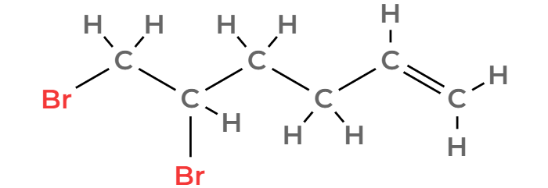
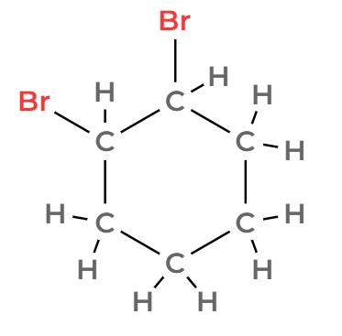

(-1 mark for minor errors)
Total | 4

Question 33 (7 marks)

(a) Identify the carbohydrate / sweetener that exhibits the strongest interactions with the stationary phase. Justify your choice. (3 marks)

Description | Marks
Fructose | 1
Recognition that strong interactions with the stationary phase would results in slow movement through the column. | 1
Recognition that fructose has the longest retention time. | 1
Total | 3

(b) Identify which chromatogram (A, B or C) is likely to represent plain yoghurt. Justify your answer. (2 marks)

Description | Marks
C | 1
Less sweeteners present / No fructose (from fruit) / No glucose (from plants) / No sucrose (sugar). | 1
Total | 2

(c) Identify which chromatogram (A, B or C) represented the yoghurt with the lowest concentration of galactose. (1 mark)

Description | Marks
A | 1
Total | 1

(d) Using the calibration curve above, determine the concentration of galactose, in parts per million, in this yoghurt sample. (1 mark)

Description | Marks
600 ppm (allow ± 125 ppm) | 1
Total | 1

Question 34 (6 marks)

(a) Define an acid according to the Arrhenius theory. (1 mark)

Description | Marks
Recognition that acids produce H⁺ ions in solution. | 1
Total | 1

(b) Define the term ‘weak’ as it relates to the nature of an acid. (1 mark)

Description | Marks
Recognition that weak acids undergo partial ionisation. | 1
Total | 1

(c) Write an equation which illustrates acetylsalicylic acid behaving as a weak acid. (2 marks)

Description | Marks
C₉H₈O₄(aq) ⇌ C₉H₇O₄⁻(aq) + H⁺(aq)
Correct species | 1
Double arrow | 1
Total | 2

(d) Calculate the percentage by mass of carbon in acetylsalicylic acid. (2 marks)

Description | Marks
M(C₉H₈O₄) = 180.154 g mol⁻¹ | 1
% C = (9 x 12.01) / 180.154 x 100  = 60.00% | 1
Total | 2

Section Three: Extended answer 40% (74 marks)

Question 35 (17 marks)

(a) Label the identity of the residue and the filtrate in the boxes on the diagram above. Include state symbols for each. (2 marks)

Description | Marks
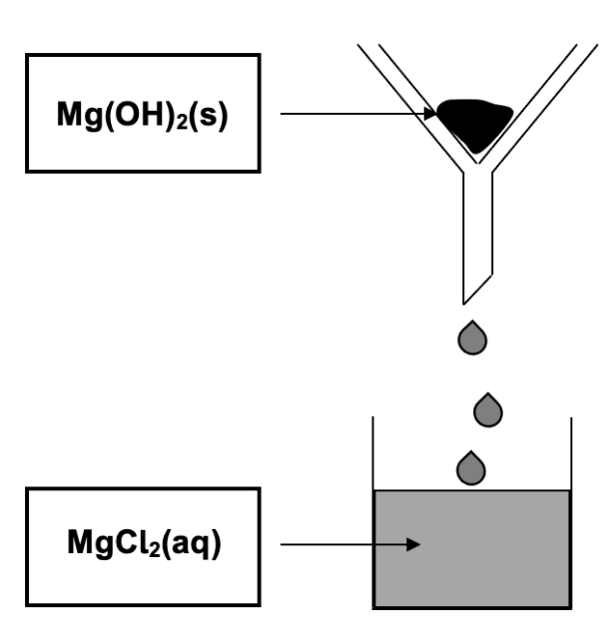  Award 1 mark per correct box. State symbols must be shown. | 2
Total | 2

(b) Write a balanced molecular equation for the reaction that would take place. (2 marks)

Description | Marks
Mg(OH)₂(s) + 2 HCl(aq) → MgCl₂(aq) + 2 H₂O(l)
Correct species | 1
Correct balancing | 1
Total | 2
Note: award full marks for balanced ionic equation (molecular requested to aid comprehension of part (d))

(c) Calculate the mass of compound B in the filtrate. (2 marks)
Description | Marks
n(Mg²⁺ in filtrate) = 0.121 x 0.115  = 0.013915 mol  = n(MgCl₂) | 1
m(MgCl₂) = 0.13915 x 95.21  = 1.32485 g | 1
Total | 2

(d) Calculate the volume of HCl(aq) that would be required to react with all of the residue. (4 marks)
Description | Marks
m(Mg(OH)₂) = 2.91 – 1.32485  = 1.5852 g | 1
n(Mg(OH)₂) = 1.5852 / 58.326  = 0.027177 mol | 1
n(HCl required) = 2 x n(Mg(OH)₂)  = 0.054355 mol | 1
V(HCl) = 0.054355 / 0.274  = 0.198 L | 1
Total | 4

(e) Calculate the concentration of chloride ions present in this final mixture. (4 marks)

Description | Marks
n(Cl⁻ from MgCl₂) = 2 x n(Mg²⁺ in filtrate) from part (c)  = 0.02783 mol | 1
n(Cl⁻ from HCl) = n(HCl required) from part ()  = 0.054355 mol | 1
n(Cl⁻ total) = 0.02783 + 0.054355  = 0.082185 mol | 1
c(Cl⁻) = 0.082185 / 0.313  = 0.263 mol L⁻¹ | 1
Total | 4

(f) Draw a labelled diagram, showing the predominant forces acting between the chloride ions and the surrounding water molecules in this mixture. (3 marks)

Description | Marks
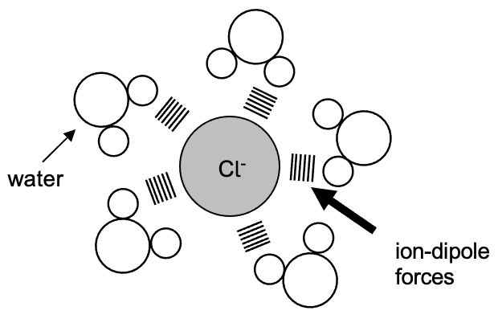

Water molecule and Cl⁻ ion clearly drawn or labelled | 1
Ion-dipole forces labelled | 1
Water molecules oriented correctly towards the Cl⁻ ion | 1
Total | 3

Question 36 (17 marks)

(a) Complete the following table by drawing Lewis structures, and stating the shape of both the hypochlorous acid and nitrogen trichloride molecules. (4 marks)

Description | Marks
Lewis structure diagram Shape  HOCl v-shaped / bent  NCl₃ pyramidal  Award 1 mark per correct cell. | 4
Total | 4

(b) Briefly outline the valence shell electron pair repulsion (VSEPR) theory, and describe how it can be applied to predict each of the shapes in part (a). (4 marks)

Description | Marks
Recognition that VSEPR involves repulsion between electron pairs. | 1
Recognition that this repulsion occurs between both bonding and non-bonding electron pairs (around the central atom). | 1
Recognition that HOCl has 2 bonding and 2 non-bonding pairs of electrons around the central atom (and is therefore v-shaped). | 1
Recognition that NCl₃ has 3 bonding and 1 non-bonding pairs of electrons around the central atom (and is therefore pyramidal). | 1
Total | 4

(c) Explain, in terms of intermolecular forces, why the boiling point of NCl₃ is higher than that of NH₃. (4 marks)

Description | Marks
Recognition that NCl₃ exhibits dispersion and dipole-dipole forces, whilst NH₃ exhibits dispersion, dipole-dipole forces and hydrogen bonding. | 1
Recognition that NCl₃ has a greater M and therefore greater strength of dispersion forces. | 1
Recognition that the sum of intermolecular forces is greater in NCl₃. | 1
Recognition that a greater quantity of heat is required to disrupt the bonding in NCl₃ (resulting in a higher boiling point). | 1
Total | 4

(d) Explain, in terms of intermolecular forces, why NCl₃ and NH₃ display such different solubilities in water. (5 marks)

Description | Marks
Recognition that NH₃ and H₂O both exhibit hydrogen bonding (in addition to dispersion and dipole-dipole forces). | 1
Recognition that NH₃ and H₂O can form new hydrogen bonds when mixed. | 1
Recognition that the energy released in the formation of these new hydrogen bonds is sufficient to overcome the existing intermolecular forces within the H₂O and NH₃ (and thus dissolving occurs). | 1
Recognition that NCl₃ is less polar than NH₃.  or  Recognition that NCl₃ exhibits predominantly dispersion forces.  or  Recognition that NCl₃ does not exhibit hydrogen bonding. | 1
Recognition that formation of new forces between NCl₃ and H₂O would be minimal (and thus dissolving does not occur).  or  Recognition that the energy released when new forces form between NCl₃ and H₂O is not sufficient to overcome the existing intermolecular forces within H₂O and NCl₃ (and thus dissolving does not occur). | 1
Total | 5

Question 37 (19 marks)

A chemistry teacher gave her class four separate solutions labelled A, B, C and D. The identities of the solutions were;

- 0.15 mol L⁻¹ HNO₃(aq)
- 0.15 mol L⁻¹ K₂CO₃(aq)
- 0.15 mol L⁻¹ Ba(OH)₂(aq)
- 0.15 mol L⁻¹ Na₂SO₃(aq)

She then asked the students to design and perform an investigation that would correctly identify A, B, C and D.

The students decided to mix a small amount of each solution with each of the other three solutions. They drew up a table and recorded their results. The initial data they collected is shown below.

 | A | B | C | D
A |  | white precipitate formed | no change observed | no change observed
B |  |  | colourless gas produced | no change observed
C |  |  |  | colourless gas produced
D

a) Which two solutions must have been mixed to produce the white precipitate? Write a balanced ionic equation for this reaction, include states. (4 marks)

- K₂CO₃ (1)
- Ba(OH)₂ (1)
- Ba²⁺(aq) + CO₃²⁻ (aq) BaCO₃ (s) (2)
Ionic – (1 mark), balanced – (1 mark)
Balanced molecular 1 mark maximum.

Two different solution combinations (C + D and B + C) produced colourless gases.

b) Write balanced chemical equations showing how each of these gases was produced. (7 marks)
2 HNO₃(aq) + K₂CO₃(aq) → 2 KNO₃(aq) + CO₂(g) + H₂O(l)
(1 mark) (1 mark) Products (1 mark) Balanced (1 mark)

OR 2 H⁺(aq) + CO₃²⁻(aq) → CO₂(g) + H₂O(l)

2 HNO₃(aq) + Na₂SO₃(aq) → 2 NaNO₃(aq) + SO₂(g) + H₂O(l)
(1 mark) Products (1 mark) Balanced (1 mark)

OR 2 H⁺(aq) + SO₃²⁻(aq) → SO₂(g) + H₂O(l)

One group of students had noted an additional observation which they shared with the class.
“The gas produced from the reaction between C + D had a pungent odour.”

c) Identify each of the four original solutions. (4 marks)

Solution A: barium hydroxide Ba(OH)₂

Solution B: potassium carbonate K₂CO₃

Solution C: nitric acid HNO₃

Solution D: sodium sulfite Na₂SO₃

d) Define ‘acids’ and ‘bases’ according to the Arrhenius theory. Give an example of each and give any necessary equations. (4 marks)

- Acids produce H⁺(aq) in aqueous solution.
- Any reasonable equation:
H₂SO₄ 2H⁺ + SO₄²⁻

- Bases produce OH⁻(aq) in aqueous solution.
- Any reasonable equation:
NaOH Na⁺ + OH⁻

Question 38 (21 marks)

(a) State three (3) observations that would be noted as this reaction took place. (3 marks)

Description | Marks
Black solid dissolves | 1
Blue solution forms | 1
Effervescence | 1
Total | 3

(b) Explain, using collision theory, two ways that the rate of this reaction could be increased. (6 marks)
Description | Marks
State the two changes to be made | 2
Explanation using collision theory | 4
Any two of the following:

Increase temperature of the reaction mixture
- Increases the average kinetic energy of the reactant particles
- thus reactant particles are colliding with more energy/more often resulting in a faster rate of reaction.

Increase the concentration of nitric acid
- More nitric acid in same volume/reactant particles more crowded
- thus resulting in more collisions between the reactant particles which increases the rate of reation.

Use powdered or smaller pieces of copper II sulfide
- Increases the surface area of the copper II sulfide
- therefore more copper II sulfide exposed to the acid resulting in more collisions between the reactant particles thus increasing the rate of reation.
Add a suitable catalyst
- Adding a catalyst lowers the activation energy required for a successful collision
- thus more reactant particles have sufficient energy when they collide (with the correct orientation) thus increasing the rate of reaction.

Total | 6

(c) Calculate the concentration of nitric acid required, to ensure all the copper(II) sulfide reacts. (4 marks)

Description | Marks
m(CuS) = 93.3 / 100 x 612 x 10³  = 570996 g | 1
n(CuS) = 570996 / 95.61  = 5972.14 mol | 1
n(HNO₃) = 8 / 3 x n(CuS)  = 15925.698 mol | 1
c(HNO₃) = 15925.698 / 6500  = 2.45 mol L⁻¹ | 1
Total | 4

(d) Complete the table below, by drawing Lewis structures for both compounds. (4 marks)

Description |  | Marks
HNO₃ |  | 2
CuSO₄ |  | 2
Total |  | 4
Note: award one mark if brackets and charges are not shown for CuSO₄, or in the case of other minor errors

(e) Explain why each of these substances conduct electricity when dissolved in aqueous solution. Distinguish between the processes of dissociation and ionisation in your response. (4 marks)

Description | Marks
Recognition that both substances have mobile charge present. | 1
Recognition that this charge is in the form of freely moving ions.  (This may be represented using equations such as  HNO₃ → H⁺ + NO₃⁻ and CuSO₄ → Cu²⁺ + SO₄²⁻) | 1
Recognition that CuSO₄ dissociates as it exhibits ionic bonding. | 1
Recognition that HNO₃ ionises as it exhibits covalent bonding. | 1
Total | 4

